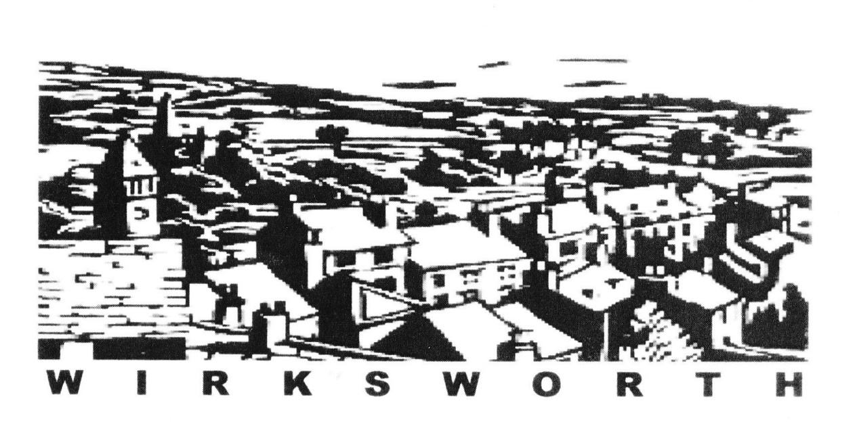
Wirksworth Twinning Association
welcomes friends from Die and Frankenau
22 to 26 June 2023
Programme of Events to celebrate
the 30 years of Twinning Die - Wirksworth
“Welcome to Wirksworth”
We hope everyone will attend the Friday evening Welcome Reception, but all other activities are optional. Dip in and out as you and your guests wish but please note that there are limited places for some activities, marked**so please sign up on Friday evening.
Our shared planet
Sustainable development. Where a society meets human needs without undermining our planet’s integrity and doesn’t compromise the ability of future generations to meet their needs

Thursday 22 June

15.00-16.00 Frankenau visitors arrive Memorial Hall

17:00-18:00 Die visitors arrive Memorial Hall

Evening meal with hosts.
Friday 23 June
10.00-10.25 Introduction to the Heritage Centre
10.35-11.00 Introduction to St Mary’s Church
11.15-12.15 Twinning film clips showing at
Northern Light Cinema
14.30-16.00 Wirksworth Walking Tour – meeting point: Memorial Hall
17.00-18.30 Welcome reception at the Town Hall
– drinks and nibbles
Enter by main door. Displays by various local businesses and groups, working towards sustainable development, reduction of carbon emissions and careful use of resources.
Welcome by Sean Barker, mayor of Wirksworth and responses from our twin towns.
Presentation by Aquabox , a portable water purification kit sent to areas of the world suffering from natural and man-made disasters

Evening “Fuddles” (shared meals) in hosts’ and helpers’
homes. Groups to be advised.
Saturday 24 June
10.00-11.30 Tour of the Aquabox Depot**, Cromford Hill
11.00-16.30 Bakewell Day of Dance – dance performances and participation in the streets of Bakewell
10.00-11.00 Yoga** - mats and blankets will be provided, in the Town Hall
11.30-12.30 Drumming** workshop in The Maltings
12.00-17.00 Wirksworth Hidden Gardens & Courtyards
Tickets cover entry to gardens on both Saturday and Sunday and will be sold at Marsdens, Greengates (Coldwell Street) and in front of the Memorial Hall.
There is no charge for guests but please ask them to wear the Twinning badges provided.

15.30– 16.30 Soul Voices** – singing workshop in The Maltings

Saturday Evening

Celebration Meal in the Town Hall

18.15-18.45 Arrive at the Town Hall via the garden entrance
and enjoy welcome drinks.

18.45-20.15 Take places at the tables in the Main Hall (upstairs) for the meal and speeches

20.30-21.00 Coffee

21.00-23.00 Entertainment by Rob Gill and Friends

Sunday 25 June
Church Services 09.00 St Teresa’s (Catholic)
09.30 St Mary’s (Church of England)
10.00 West Derbyshire United Reformed Church
10.30 Wellspring (Baptist and Methodist)

10.00-11.30 Clay modelling** in the Town Hall Bar
11.30-12.30 Bauhaus talk by Conny Müller**, Frankenau
Town Hall Council Chamber
13.00-15.00 Meeting for committee members from Die,
Frankenau and Wirksworth, light lunch with
Alastair and Suzanne Clark(e) , 34, Willowbath Lane
12.00-17.00 Hidden Gardens & Courtyards of Wirksworth

16.00-17.00 Clog dancing** in the Memorial Hall

Evening meal with hosts
20.30-22.00 informal Music Session in the Royal Oak Barn, voices and instruments welcome – come along, drop in and enjoy a sing-song!

Monday 26 June
Die departure from Wirksworth: 07.00 - Memorial Hall
Frankenau departure from Wirksworth: 15.00 – Memorial Hall

